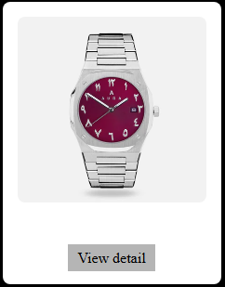

**Product Name:** Classic Silver Wristwatch with Arabic Numerals

**Detailed Description:**

This classic wristwatch features a sleek, stainless-steel band and casing, giving it a modern and refined look. The round black dial is highlighted by Arabic numerals, offering a unique cultural and aesthetic touch. Its minimalist design ensures versatility, suitable for both everyday use and formal occasions.

Crafted with durability in mind, the stainless-steel strap is resistant to wear and tarnish. The watch is powered by a reliable quartz movement, ensuring accurate timekeeping. Its lightweight build and secure clasp provide all-day comfort and security on the wrist. This piece combines traditional numeral styling with contemporary design, making it a standout accessory for anyone who appreciates functional elegance.

**Key Features:**

* Black dial with Arabic numerals
* Stainless steel case and band
* Quartz movement for precise timekeeping
* Secure deployment clasp
* Unisex design
* Splash-resistant

**Price:** $79.99 USD